Introduction to Network Monitoring

Que. 1. Does Wireshark capture all the traffic on the Internet? If so, explain why. If not, which traffic does it capture?

Ans.This actually depends on how the network is configured. The PC running the sniffer must have its Ethernet interface put into promiscuous mode so that it listens to all frames that it can hear. On a network using hubs (Ethernet) this is all that's needed to "hear" all of the local traffic. In most cases the Ethernet will be using switches instead of hubs which prevents all of the PCs from "hearing" each others traffic. In this case the switch must be configured to copy all of the local traffic to the port the PC running the sniffer is connected to.

Wireshark can capture traffic to/from your PC on the interface of your choice. So you might choose Ethernet or Wi-Fi for example. Unless you have a setup where your PC has a direct connection to the Internet (for example via PPPoE) your Internet traffic will go through a router to your provider. Wireshark can’t directly see what your router is doing; it only captures what you are sending on your local network before it goes to the router. Essentially that is the same traffic, though.
You’ll want to set a packet filter in Wireshark so that it ignores traffic that is unrelated to what you want to analyze. Otherwise you will see all sorts of things happening on your local network, like PCs talking to each other or printers doing random things.
Wireshark can see encrypted packets headed to a mail server or website, but it can’t decrypt them.

But sir the main thing I found is Wireshark not capture packets of another devices connected to wifi if promiscuous mode is off If promiscuous mode is off, then the driver should only return frames that are either sourced or destined for you. There are lots of broken drivers that are always in promiscuous more or where promiscuous mode doesn't work.
In particular for Wi-Fi, your node may not be able to decrypt the packets sent by or to another system.

Que. 2. Write Wireshark filters to: View UDP traffic when scan is performed

ANS: Sir I don’t use wireshark that much but this are the only filters I know or have used.
- udp.checksum
- udp.dstport
- udp.checksum_bad
- udp.length
- udp.checksum_good
- udp.port

Que. 3. View ICMP traffic from any address.

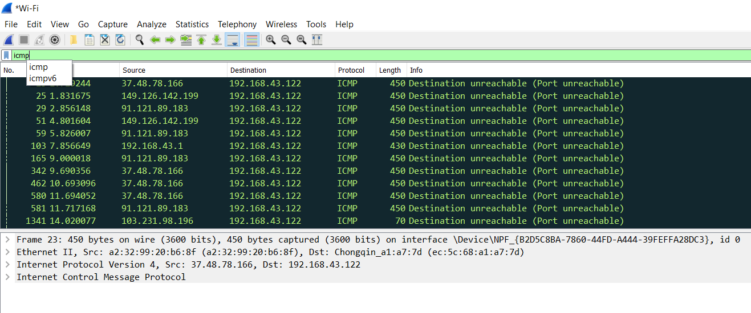

Ans.
Select the first ICMP packet, labeled Echo (ping) request.
Observe the packet details in the middle Wireshark packet details pane. Notice that it is an Ethernet II / Internet Protocol Version 4 / Internet Control Message Protocol frame.
Expand Internet Control Message Protocol to view ICMP details.
Observe the Type. Notice that the type is 8 (Echo (ping) request).
Select Data in the middle Wireshark packet details pane to highlight the data portion of the frame.
Observe the packet contents in the bottom Wireshark packet bytes pane. Notice that Windows sends an alphabet sequence during ping requests.

Sir the filters regarding this which I know are cmpv6.all_comp icmpv6.option.name_type.fqdn icmpv6.checksum icmpv6.option.name_x501 icmpv6.checksum_bad icmpv6.option.rsa.key_hash icmpv6.code icmpv6.option.type.

Que. 4. Why do ARP packets not have IP headers?

Ans. No, arp has its own protocol identifier. If they were encapsulated in ip header, then it would be just ip as the protocol. ... ARP is used to translate Layer 3 addresses (e.g. IPv4) into Layer 2 addresses (e.g. MAC address). In order to be transported in an IPv4 network in Layer 3, the ARP is encapsulated in an IP packet.

Que. 5. Compare and contrast UDP and TCP headers.

Ans.UDP: Someone hands the courier a message who throws it as hard as they can in the direction of the receiver before they walk away.
TCP: Someone hands the courier a message and who writes a sequential number on it, makes a copy, and throws the original as hard as they can in the direction of the receiver and waits for a reply, which they hand back up to the sender. If they don’t get a reply, they make another copy and send that. When they do get a reply, they hand it to the sender and they discard their copy. If the replies come in out of order, they arrange them in the right order before handing them to the sender.
In the UDP case, the sender has more responsibility in message delivery. In the TCP case, the courier has more responsibility.
The sender has to “pay more” in memory, delay, and overhead to the courier in the TCP case. In some situations, it’s not worth the added cost for guaranteed message delivery.

Q6. Do ICMP packets specify a port?

Ans.ICMP doesn’t have ports. Ports are not defined for all the IP protocols (of which ICMP is one); only for TCP and UDP.

ICMP will not send messages about ICMP messages; if this were to happen, it would create a feedback loop – a returned ICMP message would generate an ICMP message back to the other side, which would generate another message, and so on, creating a storm of ICMP packets that would quickly flood a network.
For this same reason, ICMP will not reply to broadcast or multicast addresses. Unlike other IP protocols such as TCP and UDP, ICMP does not exchange data between hosts.
Sir I but only tell part of the story. ICMP has message types, and different message types get different responses or provide information about different network conditions.

